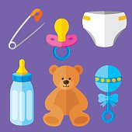Sioux empire’s biggest baby shower for the alpha center – feb. 2, 2025

All New baby items will be gladly accepted and appreciated. thank you!

At this time these are the most urgently needed baby items:

* **Gender Neutral Newborn Pacifiers**
* **4 oz. Gender Neutral Bottles**
* **Diapers – Size 5 & 6**
* **Size 18 – 24 Month Boy & Girl Pajamas**
* **Electric Baby Swings**
* **Gender Neutral Newborn Socks & Pajamas**
* **toddler Boy & Girl Socks**

These items are essential for ensuring the health and comfort of newborns and infants in our care. You can shop our Baby Items Wish List and send items directly to us for convenience and ease.

<https://my.babylist.com/alpha-center>

Always Needed Baby Items

* **Pacifier Chains**
* **Infant and Toddler Toys**

**We will be collecting items the month of January and first Sunday, Feb. 2nd, culminating with a Baby Shower on February 2nd, complete with cake and coffee. Monetary gifts can also be given (checks made out to: Alpha Center).**

**Thank you in advance for your participation!**